Glen Ridge Recreation: Something For Everyone!

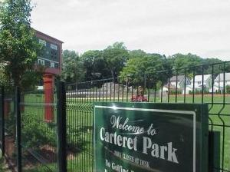

For Kids

• Summer Day Camp: This program has been a Borough staple for over 25 years! It is a 7-week program, ending the first week in August. It serves ages 5 to 12, and runs Monday through Friday, 9am-3pm, at Forest Avenue School. Activities include trips, arts & crafts, field games, board games, and swimming. A registration fee is required. Register at the Recreation office in the Glen Ridge Senior - Community Center.
• Multi Sports Camp For Kids: By popular demand, this program for ages 5 to 12, is designed to introduce fifteen different sports – everything from basketball, football and baseball to volleyball, badminton and cricket. Sponsored by Glen Ridge Recreation and operated by US Sports Institute, it will run from August 6-10. Register at the Recreation office in the Glen Ridge Senior - Community Center.

For Families

• Open Mic Night: Join the community in song! Sponsored by MAC, this program is aimed at young performers but is open to all ages, free of charge. Open Mic Night is the last Friday of each month , starting at 8pm, at the Glen Ridge Senior-Community Center.
• Porch Daddies: Grab your guitar, or your drum, or your harmonica, or whatever, and join the "open jam" at the Glen Ridge Senior - Community Center, the last Wednesday of each month at 8pm. Despite its name, this program is open to all, free of charge.
• Freeman Tennis Courts: Located on Woodland Avenue, the six clay courts are open seven days a week (weather permitting), April (date to be announced) through October. Residents under 19 play for free. Lessons and clinics for all ages are available. A membership fee required, and registration is at the Courts.

For Active Seniors

Although the annual dues of the Golden Circle are a mere $5, one need not be a member to take advantage of the various programs offered by the town to residents 55 years or older. Weekly activities include an Exercise Class on Mondays, a Sewing and Knitting Club (which donates baby blankets and hats to local hospitals) on Wednesdays, and a shuttle trip to Brookdale Shop Rite on Fridays.

Monthly programs include the Golden Circle membership meeting on the first Tuesday and the Health Lecture Luncheon on the third Tuesday, shuttle trip to Willowbrook Mall, and a field trip, such as to the Thomas Alva Edison house in West Orange. A longer field trip, perhaps to Pennsylvania Amish country, is being considered for the fall.

So join the Golden Circle for its membership meeting on May 1 at 10am; or come for lunch on May 22 at 11am. Good fellowship awaits!

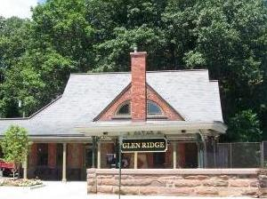

FOR INFORMATION ABOUT THESE PROGRAMS OR ABOUT RENTING THE TRAIN STATION FOR AN EVENT, CONTACT JIM COWAN, DIRECTOR OF RECREATION AT 973-748-2924 OR jtcowan@glenridgenj.org.

Page 4

